Page1

Fire Alarming System

***Mini Project Report submitted in partial fulfillment. of the requirement for the degree of***

**T. E. (Information Technology)**

Submitted By

**Name of the student:**

1. Rushikesh Tayade (19101B0008)

2. Ankit Shahane (19101B0075)

**3.** Sahil Pote (19101B0066)

Under the Guidance of

Prof. Vinita Bhandiwad

Department of Information Technology



Vidyalankar Institute of Technology

Wadala(E), Mumbai 400 037

University of Mumbai

2021-22

CERTIFICATE OF APPROVAL

Page2

**For**

**Mini Project Report**

This is to Certify that

**Name of the student’s:**

1. Rushikesh Tayade (19101B0008)

2. Ankit Shahane (19101B0075)

**3.** Sahil Pote (19101B0066)

Have successfully carried out Mini Project entitled

“**Fire Alarming System**”

In partial fulfillment of degree course in

Information Technology

As laid down by University of Mumbai during the academic year 2021-22

Under the Guidance of

“Prof. Vinita Bhandiwad”

Signature of Guide Head of Department

Examiner 1 Examiner 2 Principal

Dr. S. A. Patekar

Page3

**ACKNOWLEGEMENT**

We would like to express our deepest appreciation to all those who provided us the possibility to complete this report. We express our profound gratitude we give to our **Prof. Vinita Bhandiwad** Ma’am, our respectable project guide, for her gigantic support and guidance. Without her counseling our project would not have seen the light of the day.

We extend our sincere thanks to **Dr. Vipul Dalal**, Head of the Department of

Information Technology for offering valuable advice at every stage of this undertaking.

We would like to thank all the staff members who willingly helped us. We are grateful to VIDYALANKAR INSTITUTE OF TECHNOLOGY for giving us this opportunity.

The days we have spent in the institute will always be remembered and also be reckoned as guiding in our career.

**1. Rushikesh Tayade**

**2. Ankit Shahane**

**3. Sahil Pote**

Page4

**Table of Contents**

|  |  |  |
| --- | --- | --- |
| Sr. No. | Topic | Page No. |
| 1 | Introduction | 6 |
| 2 | Aim & Objectives | 6 |
| 3 | Problem Definition | 7 |
| 4 | Proposed System | 7 |
| 4.1 Block Diagram |
|  |
| 5 | Components | 9 |
| 5.1 Hardware |
| 5.2 Software |
| 6 | Project Architecture | 9 |
| 7 | Code | 10 |
| 8 | Implementation | 12 |
| 8.1 Working |
| 8.2 Circuit Diagram |
| 9 | Results | 13 |
| 10 | Conclusion & Future Scope | 13 |
|  | IEEE technical paper on project topic |  |
|  | Tinker cad experiment |  |
|  | Technical poster on Project topic |  |
|  | GitHub repository link |  |

Page5

**Abstract**

Fire alarm systems are essential in alerting people before fire engulfs their homes. However, fire alarm systems, today, require a lot of wiring and labor to be installed. This discourages users from installing them in their homes. Therefore, we are proposing an IoT based wireless fire alarm system that is easy to install. The proposed system is an ad-hoc network that consists of several nodes distributed over the house. Each of these nodes consists of a microcontroller (ESP8266 nodeMCU) connected to flame sensors that continuously sense the surrounding environment to detect the presence of fire. The nodes create their own Wi-Fi network. Once fire is detected by a node, it sends a signal to a centralized node that is triggered to send an Notification to the fire department and the user. A prototype was developed for the proposed system and it carried out the desired functionalities successfully with an average delay of less than 10 seconds.

Page6

**Introduction**

Having a fire alarm system is essential to ensure the safety of the people’s life and reduce the number of losses as much as possible. However, most of the homes lack these fire alarm systems, which might put residents into risk when fire breaks out in their home, either in their presence or absence. A wireless sensor network (WSN) is a self-configuring wireless network with minimal infrastructure that monitors physical or environmental conditions for flames, contaminants and transmits data via the network's first place. Or a receiver that can observe and analyze data. The receiver or base station serves as the interface between the user and the network. By entering a query and collecting the results from the recipient, you can get the information you need from the Internet. A wireless sensor network usually has thousands of sensor nodes. Sensor nodes can communicate with each other via radio signals. Wireless sensor nodes are equipped with sensitive equipment and computing equipment, radio transmitters and power supply components.

**Aim & Objectives**

Since nowadays, in the age of advanced technology and electronics, the life style of the human should me smart, simpler, easier, much more convenient and we should also focus on security. So, therefore; there is a need for many automated systems in human’s daily life routine to reduce danger of life and have a secure life. Here an idea of one such system named as automatic fire alarming system is very useful. As many times people don’t know where fire is taking place as. This model uses sensor technologies with microcontroller in order to make a smart device to help millions of people.

In its most basic form, system is programmed in such a way that whenever flame sensor senses any smallest flame near it will send an notification to appropriate authorities as well as it will take primitive action to lower that fire. So that there won’t be any life harm.

Page7

**Problem Definition**

Having a fire alarm system is essential to ensure the safety of the people’s life and reduce the number of losses as much as possible. However, most of the homes lack these fire alarm systems, which might put residents into risk when fire breaks out in their home, either in their presence or absence. Hence, we came up with a Fire Alarming System that monitors if flames are being produced nearby of the residence, the temperature of the surroundings are watched. Using this information we can send notification to appropriate authorities.

**Proposed System**

4.1 Block Diagram

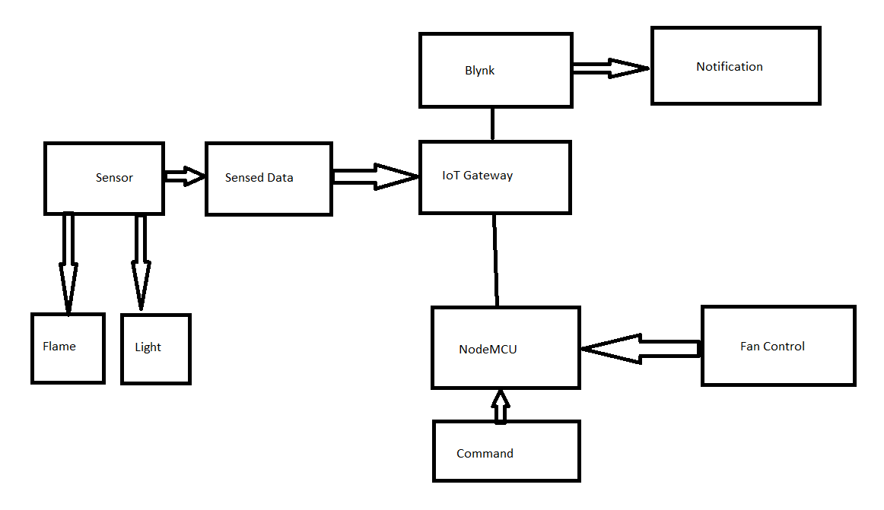

**Components**

Page8

Page9

5.1 Hardware

• NodeMCU

• Flame Sensor

• 12v DC Fan

• Relay Module

• Jumper Wires

5.2 Software

• Blynk

**Architecture**

Here we are designing fire alarming system using Iot with the help of a controller NodeMCU. Sense of flame in the surrounding is sensed with the help of flame sensor is interfaced with the NodeMCU board. And if the sensor senses the flame near it will send a notification to the owner and required authorities to their mobile phoned so that the mandatory action should be taken place. The proposed is system is for the security of people in building who have no idea how to deal with fire. This system will solve that problem by sensing and alerting the authorities. Our system also takes some preliminary action to stop the fire. As this is a demonstration of pretty large project, we are using fan to show how we can keep the fire down by putting it on automatically when flame sensor senses the flame.

This will help to reduce the danger of fire as well immediate response from fire department can be gathered.

**Code**

Page10

//IoT Based Fire Alarm Notification and control system using ESP8266

#define BLYNK_PRINT Serial

#include <ESP8266WiFi.h>

#include <BlynkSimpleEsp8266.h>

int LED = D2;

int RELAY = D4;

int Flame_sensor = D1;

int Flame_detected;

#define BLYNK_TEMPLATE_ID "TMPLIsDc00dp"

#define BLYNK_DEVICE_NAME "fire department "

#define BLYNK_AUTH_TOKEN "MI6bR4M7ckvg0jYrgUZ1m_hKkm4PhzPo"

BlynkTimer timer;

char auth[] = "MI6bR4M7ckvg0jYrgUZ1m_hKkm4PhzPo"; //Auth code sent via Email

char ssid[] = "Rushikesh";

char pass[] = "12345678";

void notifyOnFire()

{

Flame_detected = digitalRead(Flame_sensor);

Serial.println(Flame_detected);

//delay(100);

if (Flame_detected == 0) {

Serial.println("Flame detected...! take action immediately.");

Blynk.notify("Alert : Fire detected...! take action immediately.");

digitalWrite(LED, HIGH);

digitalWrite(RELAY, LOW);

delay(500);

}

else

{

Serial.println("No Fire detected. stay cool");

digitalWrite(LED, LOW);

digitalWrite(RELAY, HIGH);

}

}

void setup()

{

Serial.begin(115200);

Blynk.begin(auth, ssid, pass, "blynk.cloud",80);

pinMode(LED, OUTPUT);

pinMode(RELAY, OUTPUT);

digitalWrite(RELAY, HIGH);

pinMode(Flame_sensor, INPUT_PULLUP);

timer.setInterval(1000L, notifyOnFire);

}

Page11

**Implementation**

8.1 Working

With the help of the fire alarming system, we will get notified remotely if fire gets detected in the surroundings using flame sensor Flame sensor will continuously check the surroundings for flames or any fire symptoms if found it will notify the NodeMCU. Flame sensor has two Boolean output values which are 0 and 1.

If the flame is not detected in the surrounding it will send the value 0 and vice versa. NodeMCU is acts as WIFI module which is connected to the local WIFI and will send the notification to the cloud if flame detected. After flame gets detected we also turn on 12v DC fan to demonstrate how we can implement preliminary precautions in case of fire.

Page12

.

8.2 Circuit Diagram 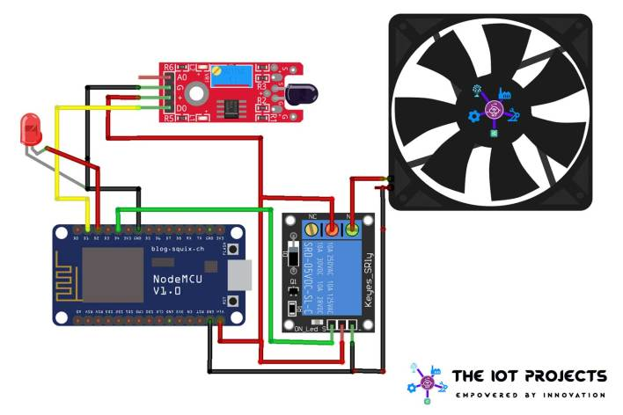

**Result**

As all the testing was done with satisfactory result. The system works with flame and Flame sensor which sends Boolean values according to the surroundings. Readings from the flame sensor in the circuit also depend on what the surroundings is for the sensor. Otherwise, overall result coming out from the circuit in terms of functionality was good for motivation.

**Conclusion and Future Scope**

Page13

From this work, we can sense the fire in the surrounding and can notify as well as take preliminary actions to prevent it. Depending upon the flame sensors reading the 12v DC fan can be turned on automatically which demonstrate the actions which can be taken. This saves danger of risking live in case of fire, in case of danger concern authorities can be remotely notified so that the required actions can be taken accordingly. Also 12v DC fan works as preliminary actions can be taken with help of relay module. This project will save lives in case of fire in corporate building as well as societies. We have taken care of the notification system such as a notification will be sent to authorities after the delay of 500 ms if fire is still there.